

**Tribhuvan University**

**Faculty of Humanities and Social Sciences**

**Online Voting System**

**A PROJECT Proposal**

**Submitted to**

**Department of Computer Application**

**Name of the College**

**Academia International College**

***In partial fulfillment of the requirements for the Bachelors in Computer Application***

Submitted by

Khagendra Malla

[6-2-346-15-2021]

Sujal Bajracharya

[6-2-346-35-2021]

February 2025

Under the Supervision of

**Ananda Adhikari**

Table Of Contents

1. Introduction 3

2. Problem Statement 3

3. Objectives 3

4. Methodology 4

4.1 Requirement Identification 4

i. Study of Existing Systems 4

ii. Literature Review 4

iii. Requirement Analysis 4

4.2 Feasibility Study 5

i. Technical Feasibility 5

ii. Operational Feasibility 5

iii. Economic Feasibility 5

4.3. System Design 5

6. Project Timeline 6

7. Supported Voting Methods 6

8. Expected Outcomes 7

9. Conclusion 7

10. References 7

# 1. Introduction

The development of an online voting system aims to modernize the electoral process by providing a digital platform for conducting elections efficiently. Traditional voting mechanisms often face challenges such as logistical constraints, administrative inefficiencies, and security concerns. These issues can hinder voter turnout and affect the integrity of election outcomes. By implementing a digital voting system, we can mitigate these problems and provide a streamlined approach that ensures accuracy, accessibility, and reliability. The adoption of online voting can significantly reduce the dependence on manual processes and facilitate more efficient elections.

# 2. Problem Statement

Current voting methods, including paper-based and electronic voting machines (EVMs), introduce risks such as miscounts, unauthorized access, and administrative overhead. Ensuring a reliable and user-friendly system is essential for fair elections. Additionally, traditional voting methods are time-consuming and require extensive manpower for administration and oversight. The high cost of paper ballots, transportation, and election day logistics further emphasizes the need for an alternative voting method. This proposal focuses on implementing an online voting system that prioritizes accessibility, accuracy, and efficiency while reducing administrative burdens and financial costs associated with conventional voting systems.

# 3. Objectives

* **Accessibility:** Enable remote voting through a user-friendly web-based interface that ensures inclusivity for all eligible voters.
* **Efficiency:** Streamline the vote-casting and counting process to reduce delays and potential errors in tabulation.
* **Accuracy:** Ensure that all votes are counted correctly without manipulation or fraud.
* **User Authentication:** Implement a simple yet effective authentication mechanism to verify voters, reducing the possibility of duplicate or fraudulent voting.
* **Cost-Effectiveness:** Minimize operational expenses through digital infrastructure, reducing the cost associated with traditional polling stations.
* **Scalability:** Develop a system that can be adapted for different election sizes, from small organizational polls to large-scale governmental elections.
* **Transparency:** Provide voters with a secure and verifiable system that allows them to confirm their votes without compromising their anonymity.

# 4. Methodology

## 4.1 Requirement Identification

### Study of Existing Systems

Current voting methodologies encompass traditional paper ballots, electronic voting machines (EVMs), and various limited online voting trials. Although EVMs reduce certain manual errors, they are still vulnerable to manipulation, technical malfunctions, and scalability issues. Moreover, online voting has not achieved widespread adoption primarily because of ongoing concerns regarding data security and the challenge of reliably verifying voter identities.

### Literature Review

Extensive academic research has highlighted both the benefits and risks associated with online voting. Historical case studies reveal that previous online voting attempts have encountered significant vulnerabilities, which offer valuable insights into mitigating risk factors in future implementations.

### Requirement Analysis

Identifying the functional and technical requirements for the system, ensuring alignment with industry standards.

## 4.2 Feasibility Study

### Technical Feasibility

The system will be developed using publicly available technologies, including HTML, CSS, PHP, JavaScript, and MySQL. These technologies provide a flexible and reliable foundation for implementation.

### Operational Feasibility

The platform will have a simple user interface to accommodate all types of voters and election administrators, making it easy to navigate without specialized technical knowledge.

### Economic Feasibility

The project will utilize free and open-source resources, making it cost-effective and financially sustainable over the long term. Eliminating physical polling stations and paper ballots will contribute to substantial cost savings.

## 4.3. System Design

* **Frontend:** HTML, CSS, and JavaScript for an intuitive and accessible user interface, ensuring a seamless voting experience.
* **Backend:** PHP for server-side processing and logic, handling user authentication and vote submission securely.
* **Database:** MySQL to store voter data and election results securely, maintaining the integrity of the election process.
* **Authentication:** A basic login system with unique credentials for voters, ensuring that only registered individuals can participate.
* **Voting Process:** Users log in, cast their votes, and receive a confirmation of successful submission. The system will generate a unique confirmation code for verification purposes.
* **Security Measures:** Implementation of encryption protocols to protect voter data and prevent unauthorized access.

# 6. Project Timeline

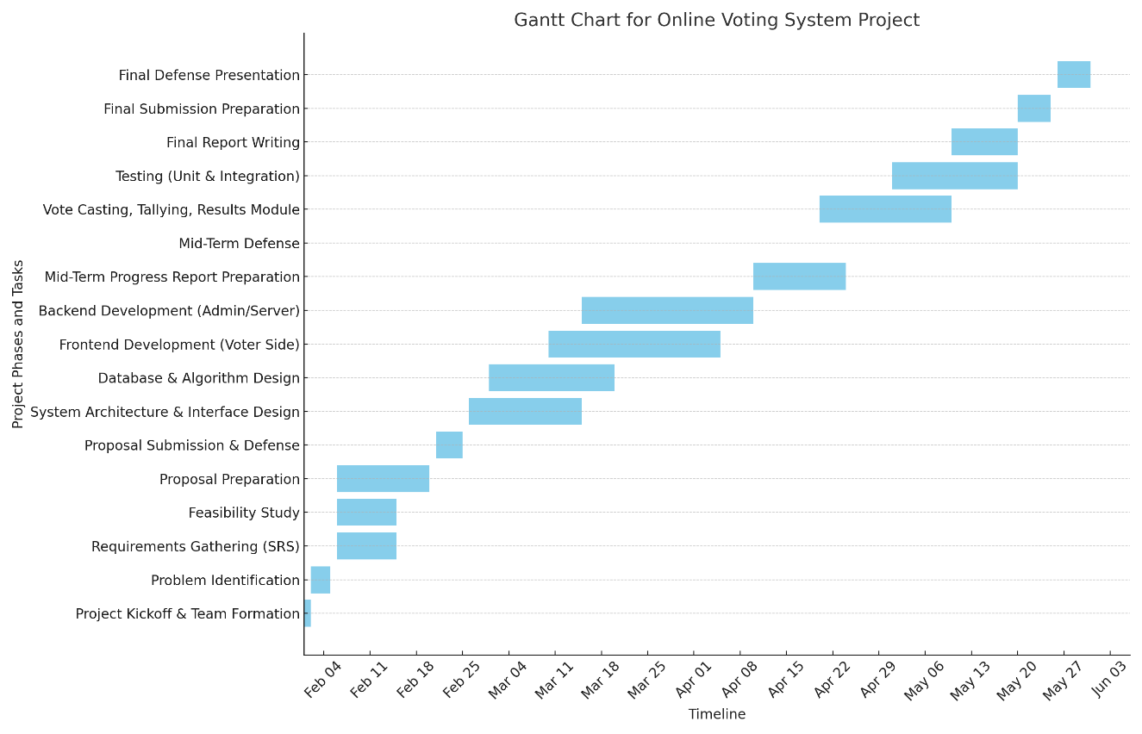

# 7. Supported Voting Methods

The system will support multiple electoral models:

* **First-Past-The-Post (FPTP)**: The candidate with the most votes wins, making it the simplest and most widely used voting method.
* **Approval Voting**: Voters can approve multiple candidates; the candidate with the highest approval wins, ensuring a fairer representation of voter preferences.
* **Ranked Choice Voting (RCV)**: Voters rank candidates in order of preference, and votes are transferred until a candidate secures a majority. This method minimizes the impact of vote splitting.
* **Single Transferable Vote (STV)**: A proportional representation method allowing votes to be transferred if a voter's preferred candidate is eliminated.
* **Score Voting:** Voters assign numerical scores to candidates, with the highest-scoring candidate winning.
* **Condorcet Method:** A candidate that defeats all opponents in head-to-head comparisons is elected.

# 8. Expected Outcomes

* A functional and secure online voting system that can be used for institutional, organizational, and governmental elections.
* A simplified and efficient election process with reduced manual effort and administrative overhead.
* Increased voter participation due to ease of access, particularly for individuals who cannot visit physical polling stations.
* A reduction in election-related costs, such as paper ballots and physical infrastructure.
* Greater confidence in the electoral process through transparency and verifiable voting mechanisms.
* A scalable platform that can be adapted for different election types and sizes.

# 9. Conclusion

This proposal presents a practical approach to developing an online voting system using free and publicly available technologies. By prioritizing accessibility, efficiency, and ease of implementation, this system will provide a viable solution for conducting secure and streamlined elections. The proposed system will not only simplify the voting process but also reduce administrative burdens, making elections more inclusive and transparent.

# 10. References

[1] J. Doe, "Digital Voting Systems and Their Impact," IEEE Transactions, 2020.

[2] A. Smith, "User Authentication in Online Elections," Cybersecurity Journal, 2019.

[3] M. Kumar, "Cost Analysis of Digital Voting," Security & Privacy, 2021.

[4] S. Brown, "Approval Voting: A Practical Approach," Political Science Review, 2022.

[5] T. Green, "Ranked-Choice Voting in Practice," Democracy Studies, 2023.

[6] L. White, "Scalability and Security in Online Elections," Computer Science Research Journal, 2021.

[7] B. Hall, "Challenges and Future Directions for Digital Elections," Journal of Governance, 2022.